Experiment 12: Implement cursors

Command:

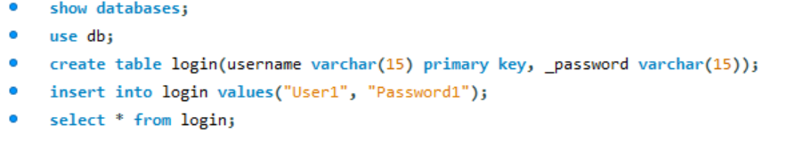

Output:

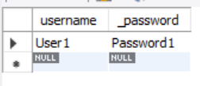

Command:

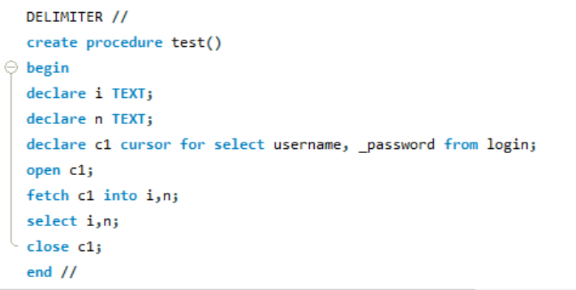

Output:



Command:

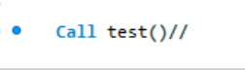

Output:

